Here is the Exercise5.1 (b) figure

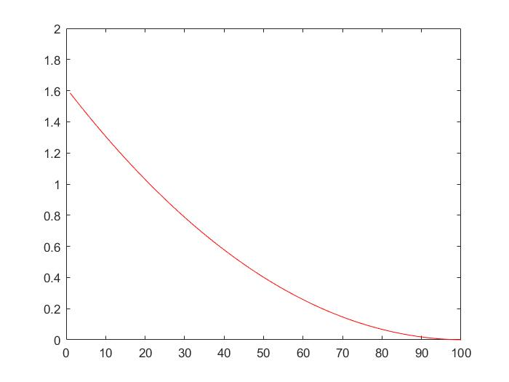

Here is the Matlab code to plot the figure

|  |
| --- |
| q=[1/2,1/4,1/4];  renyi=[];  for alpha=[0:0.01:1,1.01:1:101.01]  renyi=[renyi,(1/1-alpha).* log2(sum(q .^alpha))]  end  SHANNON=-(sum (q .* log2 (q)))  figure(1)  plot(renyi,'r')  xlim([0 100])  ylim([0 2]) |